VĂN LANG UNIVERSITY
INFORMATION TECHNOLOGY DEPARTMENT
Software Measurement & Analysis
Team: 01
Class: K15T1
Members:
Name | ID
Lê Thị Bích Vân | T09
Đỗ Minh Tâm | T09
Lê Đình Thạch Huyên | T097590
Đặng Huy Sơn | T09
Nguyễn Trung Tín | T09

Team Assignment 01
Introduction

- Brief description (≤ 3 pages) of project team roles, responsibilities and schedule (which team member plays which roles when).
- Reporting of planned and actual individual effort log data (use provided effort log spreadsheet) to Director by team, along with brief analysis

Table of Content
1. Introduction 2
2. The process of team 3
3. Team Roles and reponsibility 4
4. Meeting Schedule 5

  - Introduction
- The purpose of this document is to provide a brief summary of the regulations of the cooperation of this team and outlines its basic activities.
- This team has been created to work collectively on Software Measurement and Analysis course.
- The process of team.
- Team roles and responsibilities.
- Schedule.

  - The process of team
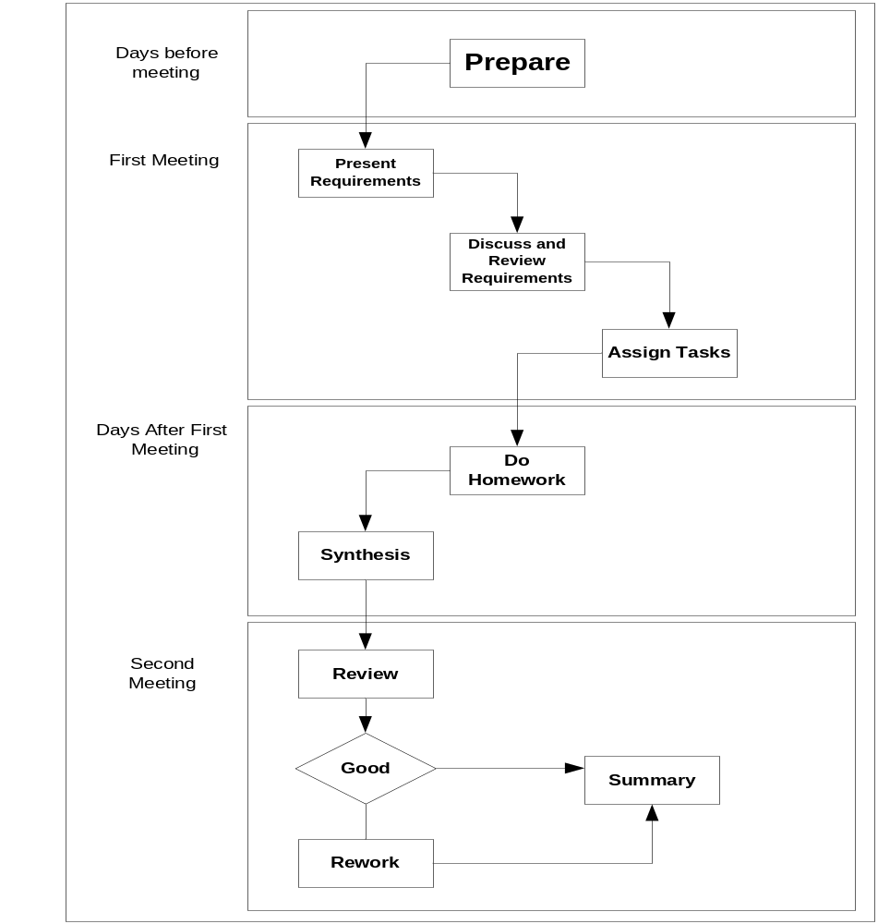

Steps | Description
Prepare | In first step, team member whom is assigned task to analysis team assignment title will preview problems in assignment.  Have to compose and delivery objects of meeting, problems need to discuss and tasks will give to each member in assignment.
Present requirement | Team member whom is assigned task to analysis team assignment title have to present the objects of meeting, problems and tasks to do for his/her team.
Discuss and review | Everybody in team will discuss the giving problems in previous step. Review objects of team assignment and tasks to do.  Everybody will modify objects and tasks to do together in this meeting after discussion.
Assisgn tasks | Team leader will assign works for each people.
Do homework | Team members will complete their works at home and send them to sub-leader.
Synthesis | Sub-leader will collect and integrated, preview final document and prepare to present.
Review | In this meeting, everybody will review and ensure assignment was finished. Documents were completed and check spelling errors.
Rework | If detect problems in documents, everybody will discuss and solve it in this meeting.
Summary | Team leader collect effort logs of people, get lessons learned together and improve process for next assignment.

  - Team roles and responsibility
- President (sponsor): Tô Đình Hiếu
- Budget approval
- Owner of the overall business change that is being supported by the project.
- Team leader: Lê Thị Bích Vân
  - Team Leader: is a member of the project team, who is responsible for the coordination of the teamwork. During the semester the Director may communicate with the Team Leader to understand project activities and status.
- Planing and schedule then assigns the activities for each of the team members. In the meeting, all of the members of the team should have been assigned their workload.
- Creates and maintains project plan
- Ensures tools and methodologies are being adhered to Reports status
- Preparing for two meetings. If necessary, Team Leader can conduct the meeting on Saturday at 1.00 pm for updating final of team assignment.
- Monitor: Prepare and after meeting. Oversees day-to-day operations.
- Review: effort log
- Evaluate the work of its members.
- Team Leader will also prepare the Power Point slides as outlined in the presentation.

- Support leader: Lê Đình Thạch Huyên:
- Support Leader analysis of the main requirements and prepare an agenda for the meeting and post it on the team website. After the meeting has been conducted, the results of the meeting must be posted on the website.
- Support Leader will have received completed parts of the assignment from other members of the team. He will then combine the whole Assignment and release (send it by email to all the members of the team and put it on the Team website) the draft of the assignment on Tuesday. Team will then comment on the whole assignment. It is a responsibility of the Team Leader to submit the Assignment on the due date of the assignment using the submission server at https://hoctructuyen.vanlanguni.edu.vn/course/view.php?id=343
- Recorder: Đỗ Minh Tâm
- Internal documentation and system documentation
- Provide resources
- Team member: System Architect, System Analyst, Developers, Testers, Technical Writer, Functional Management.
- System design and development oversight
- Develop and refine use cases
- Development and unit and integration testing of Viking
- Creates and maintains test plan
- Works with end users and system analysts to identify test populations and scenarios
- Writes test scripts
- System testing
  - Meeting Schedule
- The following dates represent the meeting schedule for team per week:
- Monday – at 10:30 am
- Wednesday – at 10:30 am to
- May be Saturday – at 10:30 am to 1.00 pm. See the section 3 to understand content in each meeting.
- Nội dung schedule cụ thể có trong file ecxel kèm theo:
- Schedule_Viking_Project_K15T1_Team1

